Project Management Plan
for
Missile Strike

Distribution:
University of Detroit Mercy

Change History:
Version | Date | Author | Changes
1.0 | 9/19 | Ravi Gowda
2.0 | 9/26 | Ravi Gowd | Format, Added more detail.

Preface
The purpose of this project management plan is to act as a guide for the completion of the project. The project is an original game where players will battle each other through strategic skills and awareness. The idea towards the project came from brainstorming ideas based on board games. The game will be a starting point for future development and if successful it may even start a sequel.
Table of Contents
1. Overview 3
2. Project Summary 3
2.1 Purpose, Scope, and objective 3
2.2 Assumptions and constraints 3
2.3 Project Deliverables 4
2.3.1 Included 4
2.3.2 Excluded 4
3. Organization 4
3.1 External Interfaces 4
3.2 Internal Structure 4
3.3 Roles and Responsibilities 5
3.3.1 Project Manager 5
3.3.2 Project-internal Functions 5
3.3.3 Project Team 5
4. Managerial Process Plans 5
4.1 Startup Plan 5
4.2 Work Plan 6
4.2.1 Work Breakdown Structure 6
4.2.2 Schedule and Milestones 6
4.3 Risk Management Plan 6
5. Technical Process Plans 7
5.1 Process Models 7
5.2 Method, Tools, and Techniques 7
5.3 Infrastructure Plan 7
6. Additional Plans 7
6.1 Communication and Reporting Plan 7
6.2 Delivery Plan 8

Overview
Missile strike will be a multiplayer game that will allow both players to combat each other in attempt to overtake all aircrafts in a designated location. This game will be an entertaining game for two players to enjoy and compete with one another. The customer will be any age group. The project will deliver a new game that others can download and play. The project will not require any funding. This project will take 3 months to complete. The project will be solely completed by myself. Future games may depend on the completion of this project. Currently this is the first game I am making and planning to release for download

Project Summary

Purpose, Scope, and objective
The purpose of the game is to locate and strike down all aircrafts on the map. The game will let two players compete with one another to decide who the fastest is to take down their targets, respectively. Each player will have their own map and their own aircrafts that are randomly generated on runtime.

Assumptions and constraints
The assumptions will be the specific goals for the project and are outlined below.
- Function goals:
- The game should allow each player to strike
- A map should be generated
- The program should display the winner
- The program should randomly organize aircrafts on every run
- The program should determine if strike location intersects with aircraft location
- The program should only allow for one player to go at a time
- Strategic goals
- The game should be challenging
- The game should have assist tools to help the player in locating a target
- Technological goals
- The game needs to run with an efficient user interface.
- Quality goals
- The game should exhibit well design and a complete program without errors

Project Goal | Priority | Comment/Description/Reference
Functional Goals: | 1 | For details see the Project Requirements Specification Error: Reference source not found
Allow each player to strike |  | Each player should be able to target a position to strike
A map should be generated |  | Each player should have a map generated before their turn
The program should display the winner |  | The winning player name and attempts should be outputted to the screen after winning
The program should randomly organize aircrafts on every run |  | Each time application is run aircrafts should be randomly generated on map
The program should determine if strike location intersects with aircraft location |  | The game should determine if the strike attempt intersects with target location and if so an output displaying “you have hit an aircraft…” should appear
The program should only allow one player to go at a time |  | The game should let player 1 go then player 2 then repeat.
Strategic Goals | 2
The game should be challenging |  | The game should be challenging enough where the player must think about his options
The game should have assist tools in helping the player locate a target |  | The game should have built in radar which acts as a guide for both players in their attempt to destroy all aircrafts
Technological Goals | 3
The game needs to run with an efficient user interface |  | The game needs a user interface efficient enough for the user to be able to play and enjoy the game.
Quality Goals | 4
The game should exhibit well design and a complete program without errors |  | The game design needs to accompany the functional, strategic, and technological goals. It should compile without errors.

Constraints: The project should be completed within 3 months. The game should be fully programmed by the end of October. November should be when testing and preparation for deployment begins.

Project Deliverables

Included
The deliverables will include the manuscript, software, and presentation of the software.

Excluded
This project will exclude testing documentation and its results.

Organization
The organization of the project consists of myself. Outside organizations affecting the project will be the University of Detroit Mercy Software Engineering committee. The external interfaces include affecting organizations. The internal structure includes the process model for the game.

External Interfaces
The project success is dependent on whether users will enjoy it or not. Stakeholders would be the general public as it’s a game meant to everyone. Subcontractor work is not needed at the time, but if the project plans on expanding then it may be needed.

Internal Structure

The project is organized to follow the software development process from start to finish. After the project management plan is devised a process model will be proposed. After this step the requirements will be made for the game which includes functional, nonfunctional, and domain constraints. After the necessary requirements are proposed the design step will come into effect. The design step will consist of: the architecture, the components, the interface, and the code. After completion of the design and code I will discuss issues and responsibilities for the game and finally conclude with a local/global impact of the project and summary of the project as a whole. Every week a progress report will be delivered to the director of the Software Engineering Program at the University of Detroit Mercy. During the end of October 2015 I will have an 10page abstract for the project.

Roles and Responsibilities

Project Manager

Role | Organization: University of Detroit Mercy
Project Manager | Ravi Gowda
Technical Project Mgr. | Ravi Gowda

Project-internal Functions

Function | Organization: University of Detroit Mercy | Comment
Quality Assurance | Ravi Gowda | Will ensure no bugs are in the program
System Test Lead | Ravi Gowda | Will ensure proper testing is taken
Validation Lead | Ravi Gowda | Will ensure the intended program is built
Configuration Mgmt | Ravi Gowda | Consistency of the program will be ensured
Change Mgmt | Ravi Gowda | Future extensions of the program will be lead by this person

Project Team

Organization: Name | Availability | Comment
Ravi Gowda | Monday-Sunday | Work will be done in between classes for the project

Managerial Process Plans

Startup Plan

4.1.2 Estimation Plan

The estimated completion of the project is three months. In those three months there should be a complete and working game and a 50 page manuscript.

Work Plan
The work will be broken down into a WBS(Work Breakdown Structure) with scheduling that will serve as a work plan for finishing the project. Deadlines need to be met to ensure the project is complete on time and that each activity has an ample enough time to complete.

Work Breakdown Structure
The Work Breakdown Structure will be broken down into what needs to be done in order for a successful project. I will be falling the proposed organization of the project.

Schedule and Milestones

Milestones |  | Description | Milestone Criteria | Planned Date
M0 |  | Start Project | Submit Proposal | 2015-09-01
 |  | Project goals and scope defined | Proposal reviewed and accepted | 2015-09-07
M1 |  | Start Planning |  | 2015-09-14
 |  | Plan and requirements | Project management plan and requirements complete | 2015-09-27
M2 |  | Start Execution |  | 2015-10-03
 |  | Architecture, component, interface, and code design. | Design complete and ready to program | 2015-10-10
M3 |  | Confirm Execution |  | 2015-10-17
 |  | Program complete | Code finished/Abstract submitted | 2015-10-31
M4 |  | Start Introduction |  | 2015-11-01
 |  | Introduction, Issues and Responsibilities, Local and Global Impact of the Project, Conclusion | Manuscript complete | 2015-11-14
M5 |  | Release Product |  | 2015-11-28
 |  | Submission of project to instructor | All deliverables submitted | 2015-12-08
M6 |  | Close Project |  | 2015-12-15

Risk Management Plan
Risks will be assessed as project is developed and recorded into a risk management log. Risks will be handled by priority as to which poses a bigger threat to the system.

Technical Process Plans

Process Models
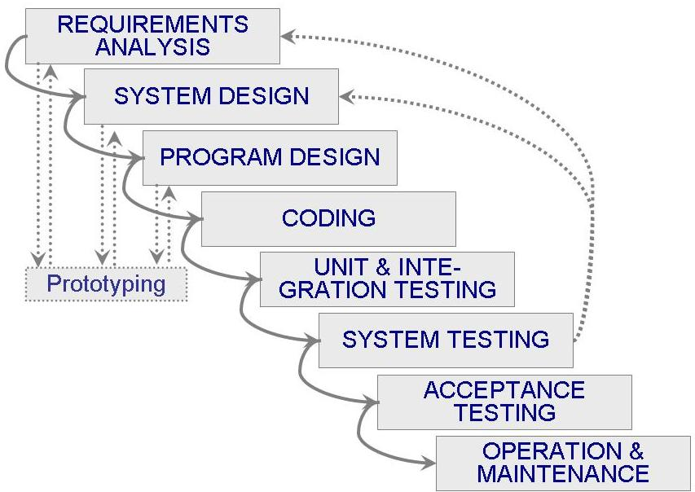

Method, Tools, and Techniques

The development process will begin with a use case diagram that will be translated into code. This diagram will follow the requirements of the game.

Infrastructure Plan

Item | Applied for | Availability by
Methods
Use Case | Requirements capturing | M2
Tools
Adobe Photoshop | Graphic design | M2
Languages
UML | Design | M2
Java | Game | M2

Additional Plans

Communication and Reporting Plan

Type of Communication | Method / Tool | Frequency/Schedule | Information | Participants / Responsibles
Internal Communication:
Project Meetings | Library | Daily | Project status, problems, risks, changed requirements | Project Manager
Sharing of project data | Office Visit | When available | All project documentation and reports | Project Manager  Director
Progress Report | Email | Weekly | Progress from that week | Project Manager  Director
Milestone Meetings | Library | Weekly | Project status (progess) | Project Manager
External Communication and Reporting:
Beta Test | User Comments | Whenever available | Review of game | Project Manager  Stakeholders

Delivery Plan

Ident. | Deliverable | Planned Date | Receiver
D1 | Abstract | 10/31/2015 | Director
D2 | Final Report | 12/08/2015 | Director
D3 | Software | 12/08/2015 | Director

